ALX AICE: Milestone #2 Worksheet

| **Simulation Recap** |
| --- |
| We hope you enjoyed the lessons and activities you completed this week. By now, we trust that you have a better understanding of the simulation and what it entails. Let’s quickly recap how this week went. You have now successfully onboarded at Waga and sent your first email to the team. In the email, you introduced yourself and suggested meeting times based on your personalized work schedule. You also included a problem statement, which was detailed and well-written, thanks to the activities you completed during the week. You also experimented with ChatGPT as a writing assistant. Now, it’s time to consolidate all the activities you completed during the week into your Milestone #2 Worksheet. Please follow the instructions provided to complete your milestone.  **Tip: Check out** [**the rubric**](https://docs.google.com/document/d/1QiceyKJmlGFKGkhTBUA5tBwLzBeLbIPgSw9BWis6VAI/copy) **before submitting your Milestone Worksheet.** |

**Step 1: AI Toolkit**

To access your AI Toolkit, Go to your personal ALX AICE Google Drive, then locate your updated [AI Toolkit Spreadsheet.](https://docs.google.com/spreadsheets/d/11HJQIo3FncvMSBTs4fZ413aPBSmLrhXnfoXx5dqoeqA/copy)

Next, Click **"Share"** (under the 3 dots) and adjust the settings so that it looks like this:



# **Then, copy the link and paste it in the box below;**

**Step 1: Your AI Toolkit**

| [AICE AI ToolKit_Habtamu_Wolde](https://docs.google.com/spreadsheets/d/1_lzTTNa11FUXXYNQqW-rTbZUhrh-9mqUyAPHh2iEo50/edit?usp=sharing) |
| --- |

*If you need more help with this, Google for video instructions on sharing files in Google Drive, or ask a peer.*

**Step 2: Your Prioritization Matrix**

Locate your [Prioritization Matrix Template](https://docs.google.com/spreadsheets/d/1K6VFgvZfyZGVabot4oQrsSxyvm8-KZejJ2FML9FFaCE/copy) from [this activity.](https://intranet.alxswe.com/projects/100385)

Next, make sure you have included at least one task under each box/tab in your prioritization matrix. (You can take out the examples we have in the worksheet)

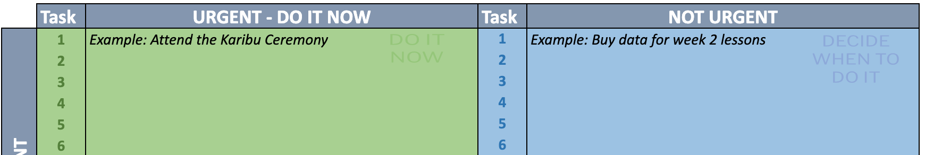

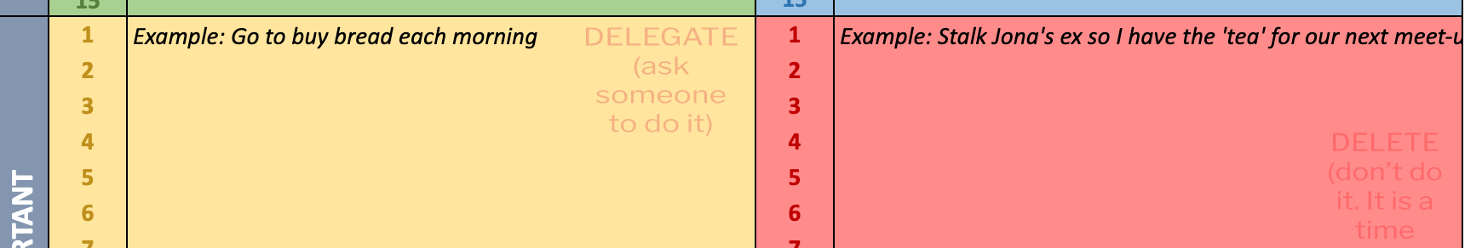

Then, Click **"Share"** (under the 3 dots) and adjust the settings to *“Anyone with the link can view.”* Next, paste the link in the box below;

**Step 2: Prioritization Matrix**

| [Prioritization-Matrix-Template-ALX AICE Program](https://docs.google.com/spreadsheets/d/1hbzS5dfSSGsp7RGKcY8LYHsc4r9PaiYD2D4PDQqSLls/edit?usp=sharing) |
| --- |

**Step 3: Work Schedule**

Locate your [work schedule from this activity.](https://intranet.alxswe.com/projects/100386) It should be titled (*AiCE_Work_Schedule)*

**Note: You are to create a work schedule based on your personal life and the activities you are carrying out in this program.**

After creating your schedule on Google Calendar, download it as a PDF following the instructions below:

Step 1: For Windows, Press Ctrl + P. If you’re using a Mac, press Command + P. This should bring up a print dialogue box.

Step 2: Set the print range to the week/s you created your work schedule.

Step 3: Click on “Print” at the bottom left to generate a PDF of your work schedule.

Step 4: Save your work schedule and rename it with this format AiCE_Work_Schedule.

Step 5: Upload your work schedule to your personal ALX drive.

Next, click **"Share"** (under the 3 dots) and adjust the settings to *“Anyone with the link can view.”*



Then, paste the link in the box below;

**Step 3: Work Schedule**

| [AiCE_Work_Schedule.pdf](https://drive.google.com/file/d/1oRyLYYZg-yIQSpZ3MzdYDuv95hwTdMIm/view?usp=sharing) |
| --- |

**Step 4: Your Personal Mission Statement**

Locate your updated [personal mission statement worksheet.](https://docs.google.com/document/d/1qEUdRGH5D37fKGXfN2oK-cby2zu0Rcg3X_U3Cp0PCSY/copy)

**Make sure you have filled out Part 3 (Write down your personal mission statement) (Steps 4-9) with at least 50 words under each step.**

Then, Click **"Share"** (under the 3 dots) and adjust the settings to *“Anyone with the link can view.”* Next, paste the link in the box below;

**Step 4: Personal Mission Statement**

| [Personal Mission Statement Worksheet - ALX_AICE_Habtamu_Wolde_2.pdf](https://drive.google.com/file/d/1roClNdP9ttDZfvM5g9S0OuxcnECgCMWl/view?usp=sharing) |
| --- |

**Step 5: Problem Statement**

Go to the problem statement you wrote from the problem statement activity. Then, paste your problem statement in the box below. Ensure your problem statement follows the structure in the box. Remember your problem statement should be based on your simulation activity at Waga. (The failed launch of VacAI)

**Step 5: Problem statement**

| **Problem description** - The Failed launch of VacAI used by customers for checking the availability of hotel service, location information is inefficient and prone to errors.  **Identifies the population** - The customers of VacAI across all over the world are impacted by the ineffective information system.  **States the impact of the problem** - The inefficiencies in the information system result in decreased app usage and downloads due to inefficiencies and potential old information Moreover, the inconsistency in hotel schedules affects customers, the hotel business firm, and the local tour guide community, leading to decreased income and potential turnover.  **Identifies a gap between the current state and the desired/solved state -** There is a significant gap between the present information database system and the desired outcome of a streamlined, user-friendly customer experience. |
| --- |

**Step 6: Your Email to Colleagues**

Locate your ["Email to Colleagues" worksheet](https://docs.google.com/document/d/1PdEja3Jk9MYvRzLyIhUNEVguCyVmRbz416a_kaw2DmM/copy). The worksheet must be filled out completely, which means that you should have filled out **Section A (Parts 1 Manual Email & Part 2 ChatGPT Email) and also completed your peer activity and reflection in Section B (Part 4).**

If it has been filled completely, Click **"Share"** (under the 3 dots) and adjust the settings to *“Anyone with the link can view.”* Next, paste the link in the box below;

**Step 6: Email to Colleagues Worksheet**

| [ALX AICE Week 2 Email Worksheet](https://docs.google.com/document/d/1aIA7IfeD_qHhWmlMO_gIckpCjdB62cgktNrQxcTbyVs/edit?usp=sharing) |
| --- |

**Step 7: Reflection on the use of AI**

Take a moment to reflect on everything you’ve learned and how AI might shape your future. Then, create a short paragraph based on your reflection; your paragraph should answer the questions in the box below;

**Step 7: Reflection on the use of AI**

| *Do you think AI can be a useful writing assistant?*  *How often do you think you will use AI as a writing assistant?*  *How can you improve your prompts?* |
| --- |

**Write your reflection paragraph here:**

| AI serves as a valuable writing assistant by offering tools for grammar correction, style improvement, content generation, language translation, research assistance, plagiarism detection, and organization. It enhances clarity, creativity, and originality while streamlining the writing process, making it an indispensable ally for writers. Since I am currently writing my thesis documentation, I am using Ai for assisting in writing my documentation.  To enhance prompts,   * I should consider providing specific examples or scenarios tailored to the user's interests or needs. * Incorporate varied vocabulary and sentence structures to stimulate creativity and encourage diverse responses. * Additionally, offer open-ended questions to prompt critical thinking and exploration of ideas. * Ensure clarity and conciseness in the prompts to facilitate understanding and encourage engagement. * By customizing prompts to resonate with users and fostering creativity through varied stimuli, the quality and effectiveness of the prompts can be significantly improved. |
| --- |